**SEO Keyword Analysis**

**Problem Statement:**

In this project, student as to do following Task

1. Already Existing Video, Extract the text from video

2. After Extracting Video Description, you need analysis the data

3. Now you need to generate AI SEO-optimized descriptions with relevant keywords, hashtags, and links.

4. If User wants to upload video into Youtube, Our AI suggest keywords/hashtags should be visible & List in SEO rankings.

Outcome: Our tool/webapp as to Generate SEO Keywords for SEO rankings, JustLike vidiQ's

Reference: <https://youtu.be/O5WyXoVl0i8>

**What is the scope of the project?**

The project aims to create an AI-powered web tool that extracts text from videos, analyses it, and generates SEO-optimized description with relevant keywords, hashtags, and links. The core tasks:

1. Extracting and analysing video transcripts
2. Generating SEO-friendly descriptions
3. Suggesting relevant SEO keywords and hashtags
4. Optimizing the entire process for YouTube or other video-sharing platforms

**What business case does the project address?**

The project addresses the business need for SEO optimization of video content. With millions of videos uploaded daily on platforms like YouTube, getting discovered by viewers is a challenge. Proper keyword usage, optimized descriptions, and relevant hashtags are critical for content visibility and ranking in search engines and within video platforms themselves.

By automating SEO-tasks, this tool helps content creators save time while maximizing their video reach and engagement. SEO optimization leads to increased traffic, more views, and ultimately higher monetization potential for videos, which is crucial for creators, brands and businesses relying on online video content.

**Who are the typical users of the solution?**

1. Youtubers and Content Creators
2. Digital Marketers
3. SEO Specialists
4. Video Production Companies
5. Businesses and Brands

**How does the solution help those users?**

1. Automated SEO Optimization – automatically generating SEO-friendly descriptions, keywords, and hashtags.
2. Improved discoverability – enhances likelihood of videos being found in search engines.
3. Increased Engagement – optimized content results in better click-through rates (CTR) and viewer engagement, reach a wider audience.
4. Data-Driven SEO – provides insights on keyword rankings and performance, helps in video content strategy.
5. Monetization Potential – better visibility leads to more views, higher ad revenue, and greater opportunities for sponsorships and partnerships.

**Optional Additional Features:**

1. For users who have linked their YouTube accounts, the app allows direct uploading of the video along with the generated description, keywords, and hashtags to the YouTube platform.
2. The tool can suggest **content ideas** based on current trends, keyword performance, and historical data, helping creators plan future video content.
3. Enable the tool to handle multilingual videos by integrating text extraction for languages other than English.
4. Integrate this for other websites like Instagram, Facebook, etc.

**User Flow Diagram:**

**Architecture Diagram:**

**Video Text Extraction:**

* **Step 1: Audio Extraction:**

**ffmpeg** for audio extraction.

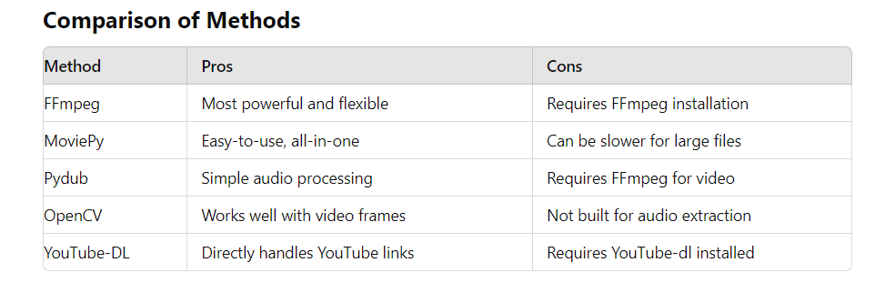

**Ffmpeg** is a powerful multimedia framework that can decode, encode, transcode, and extract audio from video files.

Download and install Ffmpeg:

1. Go to <https://www.gyan.dev/ffmpeg/builds/>
2. Click on [ffmpeg-release-essentials.zip](https://www.gyan.dev/ffmpeg/builds/ffmpeg-release-essentials.zip)87 MB [.ver](https://www.gyan.dev/ffmpeg/builds/ffmpeg-release-essentials.zip.ver) [.sha256](https://www.gyan.dev/ffmpeg/builds/ffmpeg-release-essentials.zip.sha256)
3. Extract zip file
4. Go to Environment Variables -> System Variables -> Path -> New
5. Add bin path “C:\Users\rack\Downloads\ffmpeg-7.0.2-essentials_build\bin”
6. Check in Command Prompt whether ffmpeg is installed -> ffmpeg -version

**pytube** for downloading YouTube videos.

* **Step 2: Speech-to-Text Conversion:**

**speechrecognition** for speech-to-text.

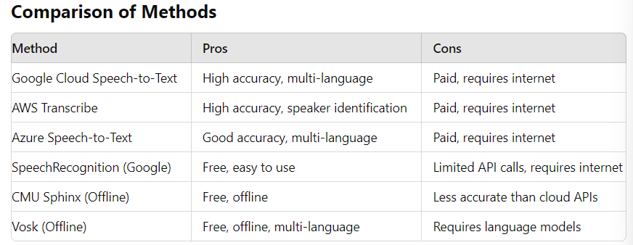

The speechrecognition library (Google Web API) in Python is an easy-to-use package that supports various APIs, including Google Web Speech, IBM, and Microsoft. It works with local audio files and offers offline recognition as well.

* **Step 3: OCR for On-Screen Text:**

**tesseract-ocr** for on-screen text extraction (OCR).

* **Step 4: Combine Text:**

**opencv-python** for frame extraction.

**Data Analysis:**

**AI SEO-Optimized Description Generation:**

**SEO Keyword and Hashtag Suggestions:**